# Home Automation Workshop SAP Labs Hungary d-shop, 8th June, 2022

During the Home Automation Workshop SAP Labs Hungary d-shop we will create a versatile microcontroller based weather station.

To maximize your experience from 1 pm to 5 pm we ask you to come with a **prepared with the following 10 minute preinstall** procedure on your laptop.

*Unfortunately, if we have too many tooling obstacles and questions the ones who come prepared will lose focus, traction and will feel a bit bored. If you experience any obstacles, just ping* [*attila.farago@sap.com*](mailto:attila.farago@sap.com) *prior to the workshop latest by 7th June.*

**Preparations steps**

Install esphome choosing your platform, below I detail out a Windows setup, but detailed steps are available for Mac as well. <https://esphome.io/guides/installing_esphome.html>

1. 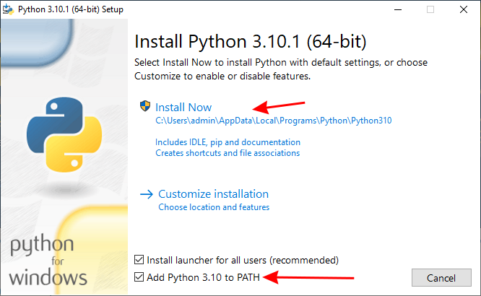**[install python]**  
   Install python from the official site  
   <https://www.python.org/downloads/>

1. Verify python installation  
   windows  
   Start menu | Command Prompt  
   enter in the command prompt:  
   python --version  
   you should see   
   Python 3.10.4

1. **[install esphome]**  
   Install esphome with dependencies  
   in the same command prompt enter  
   pip3 install wheel  
   pip3 install esphome  
   esphome version
   1. Verify python installation  
      in the same command prompt enter  
      esphome version  
      You should see:  
      Version: 2022.5.0

1. **[VSCode editor]**Install vscode as a good yaml file editor  
   <https://code.visualstudio.com/download>

1. **[Enable Mobile Hotspot]**  
   Enable wifi access point on your mobile phone and make sure you can use it e.g. from your laptop.  
     
   Alternative: pair up with another participant using his/her phone mobile hotspot.   
   Background: we will program the ESP Arduino to use a mix of local sensors and internet data sources.  
   Though it is possible to get SAP-Guest access after a registration via an additional step, SAP IT security enables IoT device usage with a second additional step of administration where we will need the specific Arduino MAC address. I have done it, yet it will just slow you down, so let’s use the phone's wifi APs.  
   We will use a few kilobytes of traffic.  
    *I will have the wifi AP of my phone as a backup.*

You are good to go, make sure you eat an apple a day and don’t let any meetings overlap with the workshop at 8th June 1pm-5pm.

**For the workshop**

Take your laptop, and charger with you.

Have your mobile phone with you.